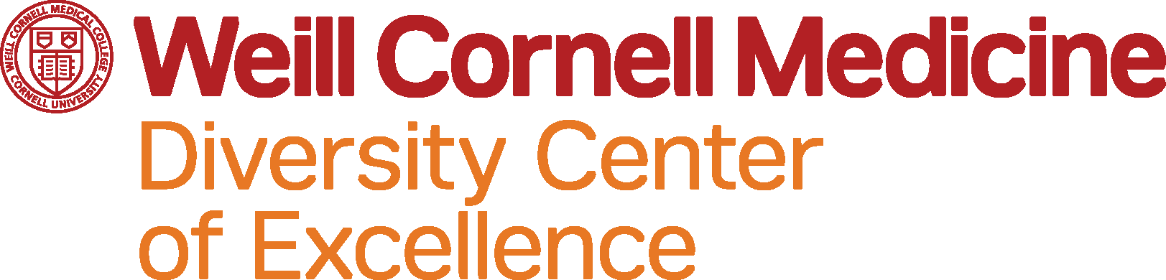

2020 Faculty Scholars in Health Equity

You are invited to apply to the Diversity Center of Excellence Faculty Scholars in Health Equity. The goal of this program is to generate a cadre of teaching faculty as institutional leaders in the development, implementation, and evaluation of curricula designed to improve integration of training in health equity and cultural competence across the entire spectrum of medical education at WCM.

We are now accepting applications from faculty of all ranks (tenure or non-tenure track), who are current or prospective clinician-educators for trainees, particularly of medical students and residents, within the School of Medicine. We welcome applications from faculty of all four campuses (NewYork-Presbyterian Weill Cornell, NewYork-Presbyterian Queens, NewYork-Presbyterian Brooklyn Methodist Hospital, and NewYork-Presbyterian Lower Manhattan Hospital). The application deadline is September 21, 2020.

The objectives of the Faculty Scholars Program are to:
- Provide education and training on leading, teaching and providing culturally responsive patient care in order to eliminate health disparities.
- Develop knowledge and skills related to curricular design and innovation focused on enhancing the provision of culturally responsive care and on integrating health equity content into curricula.
- Promote leadership and career development in medical education through scholarly productivity such as publications and leading training initiatives for health care providers at all stages of training and clinical practice.

The Scholars in Health Equity Program is a one-year faculty development program which begins with a half-day orientation in November 2020, followed by monthly two-hour didactic sessions between December 2020 through November 2021. All program participants are expected to attend the program orientation in November. Participants are expected to participate in at least 70% of the monthly education meetings consisting of videoconferences and didactic sessions. Throughout the program, all scholars will be expected to work on a capstone project, an educational innovation project to develop, redesign, or evaluate curricula to enhance learning in health equity, the social determinants of health, and/or culturally responsive care. It is expected that the project will culminate in a proposal or publication in a scientific peer-reviewed journal. The scholars will also be expected to present abstracts related to their capstone projects during the Center for Health Equity Symposium in the Spring 2021.

All interested faculty members should apply. All candidates must submit:
  - A completed application, which includes a statement of teaching philosophy
  - Curriculum Vitae (CV)
  - Statement of interest
  - Letter of Support (LOS) from their division or department chair
- Please have all materials ready to submit in Adobe PDF format as a single document
- Application deadline is September 21, 2020.
- Applicants will be notified by October 1, 2020.

For more information about the application, contact Daisy Torres-Baez (dat4004@med.cornell.edu). For more information about the program, contact Dr. Erica Phillips (erp2001@med.cornell.edu). This program is sponsored by HRSA grant D34HP31879.

APPLICATION FORM
INSTRUCTIONS:
- Assemble the required materials:
- Application form—complete all sections
- Statement of Interest (instructions below, limit 2 pages)
- Curriculum Vitae
- Letter of Support (LOS) – from a supervising senior faculty member, Dean or Chair confirming their support for a) rationale for the applicant’s attendance, b) release of time for your participation in all required activities and, c)commitment to implementing any resulting educational innovation(s)
- Submit all materials in Adobe PDF format as a single document.
- Applications must be received by email to Daisy Torres-Baez (dat4004@med.cornell.edu) by Thursday, October 1, 2020.

I. PERSONAL INFORMATION (Please type or print).

Name Degree(s)
First Middle Last
University Address
Street City, State Zip
Daytime Telephone ( ) Pager

E-Mail Address

Position/Title

Department/Division

II. STATEMENT OF INTEREST: (limit 2 pages)
- What are three motivations for your interest in participating in the Diversity Faculty Scholars in Health Equity Program?
- How do you anticipate participation in the program will benefit you and your department/division?
- What are your personal goals for the program? How does this training program relate to your career goals?
- In a few sentences, describe your philosophy of teaching.
- With regard to teaching culturally responsive health care or health equity content, what are your strengths, challenges, and opportunities?

III. CURRENT/PRIOR TEACHING EXPERIENCE
Year(s)/Semester | Course Title/Topic | Institution/Dept. | Type and number of students/ audience | Level of Effort/Time Commitment | Format
Example:  2016 | Neonatal care | Department of Pediatrics | PGY-1 residents, 6 per session | One two-hour session per week | small group discussion
IV. TRAINING PROGRAM TIME COMMITMENT
The Scholars in Health Equity is a full-year training period. Submission of this application indicates a commitment to participating in all activities as follows:
- Orientation retreat
- Monthly meetings (must attend 70% of sessions). Meetings are a mix of didactic sessions, and presentations by invited speakers.
- Educational Innovation capstone project (independent study, on your own time)
- Scholars will be highly encouraged to submit abstracts and manuscripts related to their projects
- Center for Health Equity Annual Symposium

I commit to the time involved in participating in the Faculty Scholars in Health Equity Program. I commit to attendance at least 70% of the educational activities scheduled. I certify that the information submitted in this application is true and correct to the best of my knowledge.

Electronic or Actual Signature Date

